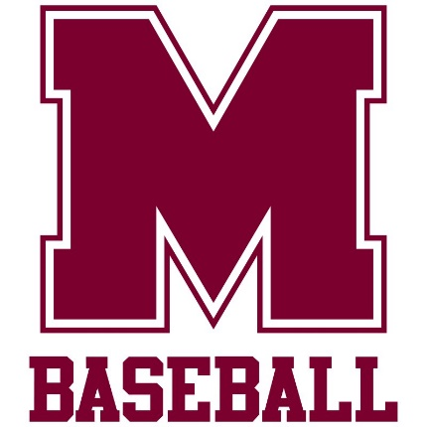

***The Montford Baseball Program’s mission is to continue the educational process and development through the game of baseball. Under that framework…***

**Montford Baseball IS…**

* A *privilege* to tryout, participate with and represent, not a right.
* A program where player character, behavior and team first focus are the focus.
* A teaching program where mental and skill development is the forefront of what we do.
* A program where academic excellence is not only required, but expected.
* A program where individual behavior choices made are met with consequences.
* A program where skills demonstrated in front of Montford Coaches are what is evaluated.

**Montford Baseball is NOT…**

* A travel team extension, recreational activity or other type of “pay for play” structure.
* A program where previous outside performance, awards, group or individual association, name or status have any impact upon evaluation, team roster status, on or off field privileges.
* A program where age, size, background or anything other than on field abilities partnered with off field character impact are considered for the privilege of being part of the program.